**Banking System**

**Task 1:**

(Screenshots are attached with Task 2)

Create database HMBank

1. Creating Customers Table:

Create table customers(

Customer_id int primary key,

First_name varchar(20) not null,

Last_name varchar(20),

DOB date,

Email varchar(40) not null,

Phone_number varchar(15) not null,

Address varchar(100)

)

1. Create table accounts

Create table accounts(

Account_id int primary key,

Customer_id int,

Account_type varchar(20),

Balance int,

Foreign key(customer_id) references customers(customer_id)

)

1. Create table Transactions

Create table transactions(

Transaction_id int primary key,

Account_id int,

Transaction_type varchar(20),

Amount int,

Transaction_date date,

Foreign key(account_id) references accounts(account_id)

)

Entity Relationship Diagram :

Customers 1 *. Accounts 1 * Transactions

Customer_id account_id transaction_id

First_name customer_id account_id

Last_name account_type transaction_type

DOB balance amount

Email transaction_date

Phone_number

Address

**Task 2:**

**1)Inserting into Customers Table:**

Insert into customers values (1001, ‘Afiya’, ‘Farheen’, ‘2003-11-29’, ‘afiyafarheen@gmail.com’, 987654321, ‘21, new street, ramapuram, chennai’)

Insert into customers values (1002, ‘Laresh’, ‘Kumar’, ‘2003-03-30’, ‘lareshkumar@gmail.com’,9878363728,’10, andavar nagar, villivakkam, Chennai’)

Insert into customers values (1003, ‘Rudravel’, ‘sankar’, ‘2004-08-24’, ‘rudravelsankar@gmail.com’,6373828288,’23, church street, Bangalore’)

Insert into customers values (1004, ‘Priyanka’, ‘Mohan’, ‘2003-10-25’, ‘priyankamohan@gmail.com’,8972627828,’2, st thomas mount, Chennai’)

Insert into customers values (1005,’Maya’,’Krishnan’, ‘2004-12-04’,’mayakrishnan@gmail.com’,7894523567,’21, royapettah, Chennai’)

Insert into customers values (1006, ‘Abishek’,’Nirmal’,’2002-08-07’,’abisheknirmal@gmail.com’,9872527167,’23,Krishna Street, Royapuram, Chennai’)

Insert into customers values (1007, ‘Vishwa’,’Vajendra’,’2003-10-09’,’vishwavajendra@gmail.com’,9282982873,’12, Maya street, anna nagar, Chennai’)

Insert into customers values (1008,’Haniya’,’Hameed’,’2004-06-11’,’haniyahameed@gmail.com’,9282782292,’16, mark antony street, besant bagar, Chennai’)

Insert into customers values (1009,’Viyanna’,’Koul’,’2001-05-23’,’viyannakoul@gmail.com’,9832738383,’9, kumbakonam street, Chennai’)

Insert into customers values (1010,’Miyanna’,’Nigar’,’2004-06-11’,’miyannanigar@gmail.com’,7282973897,’8, old street, T nagar, Chennai’)

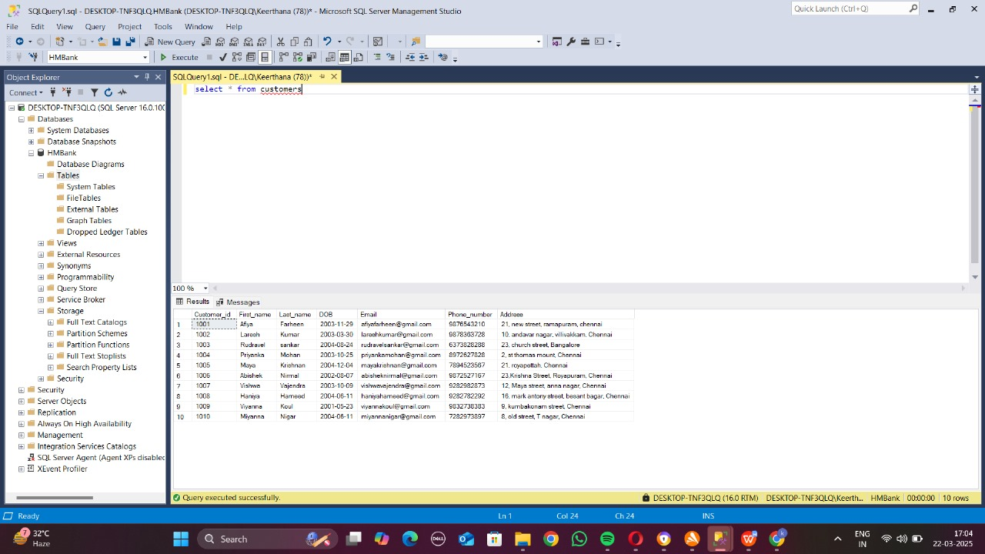

**Inserting into Accounts Table:**

Insert into Accounts values (1230,1001,’savings’,20000)

Insert into accounts values (1231,1002,’zero_balance’,25000)

Insert into accounts values (1232,1003,’current’,30000)

Insert into accounts values (1233,1004,’savings’,35000)

Insert into accounts values (1234,1005,’zero_balance’,15000)

Insert into accounts values (1235,1006,’current’,40000)

Insert into accounts values (1236,1007,’savings’,45000)

Insert into accounts values (1237,1008,’zero_balance’,42500)

Insert into accounts values (1238,1009,’savings’,33000)

Insert into accounts values (1239,1010,’current’,37500)

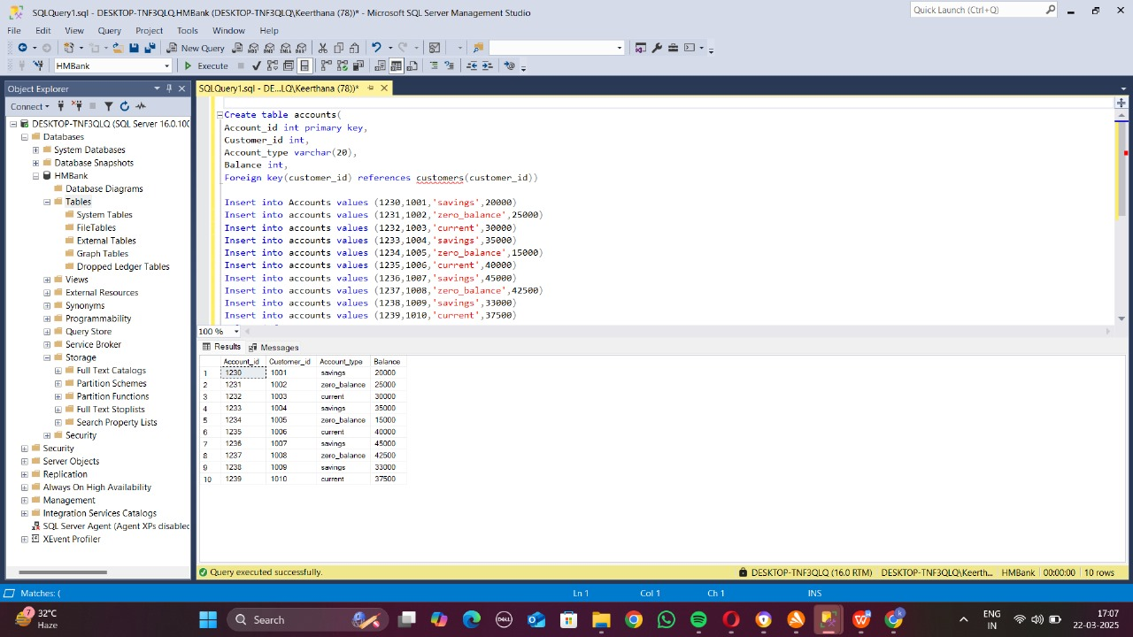

**Inserting into Transactions Table:**

Insert into transactions values (0034,1230,’deposit’,20000,’2025-03-16’)

Insert into transactions values (0035,1231,’withdrawal’,15000,’2025-02-12’)

Insert into transactions values (0036,1232,’transfer’,5000,’2025-01-13’)

Insert into transactions values (0037,1233,’transfer’,2500,’2025-02-25’)

Insert into transactions values (0038,1234,’withdrawal’,1500,’2025-01-20’)

Insert into transactions values (0039,1235,’deposit’,20000,’2025-03-01’)

Insert into transactions values (0040,1236,’withdrawal’,4000,’2025-03-03’)

Insert into transactions values (0041,1237,’deposit’,3500,’2025-02-18’)

Insert into transactions values (0042,1238,’withdrawal’,500,’2025-01-29’)

Insert into transactions values (0043,1239,’deposit’,15000,’2025-02-28’)

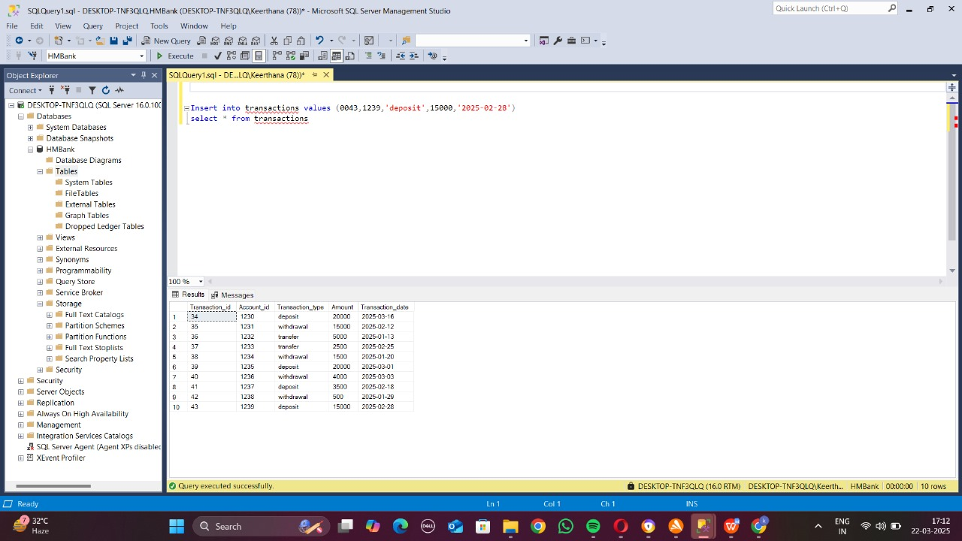

2)SQL Queries

1) select c.first_name, c.last_name, a.account_type, c.email

From customers c inner join accounts a

on c.customer_id = a.customer_id

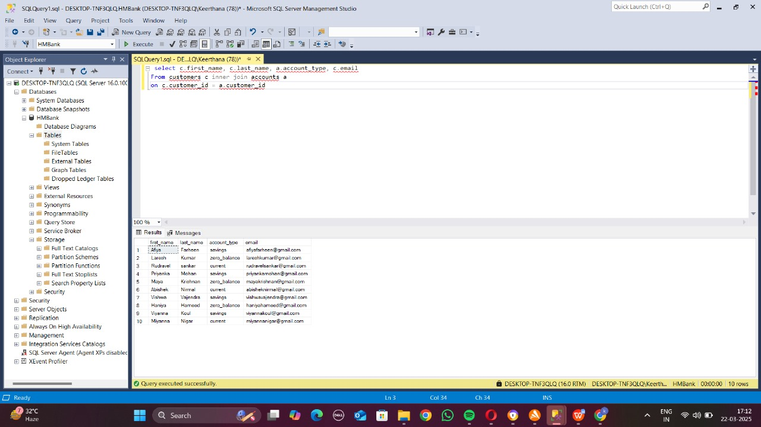

2) select * from transactions

Where account_id in (select account_id from accounts where customer_id=1002)

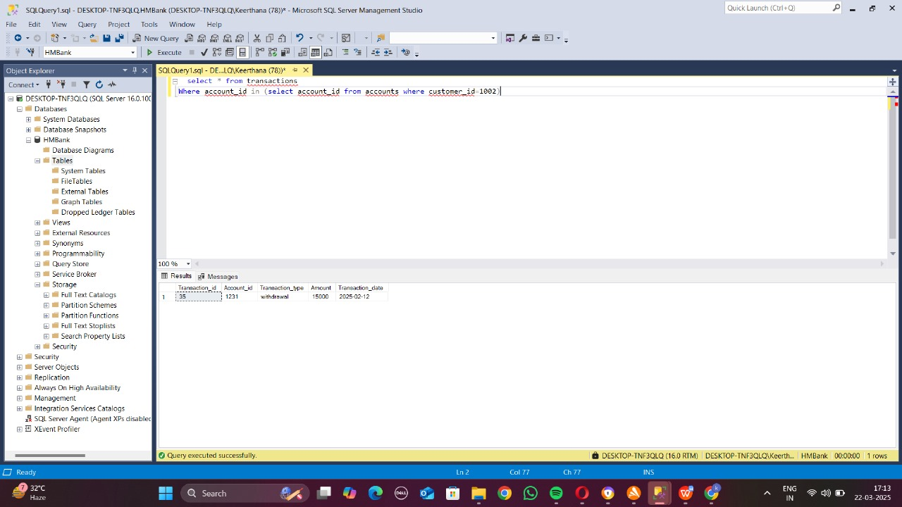

3) update accounts

Set balance=25000

Where account_id=1238

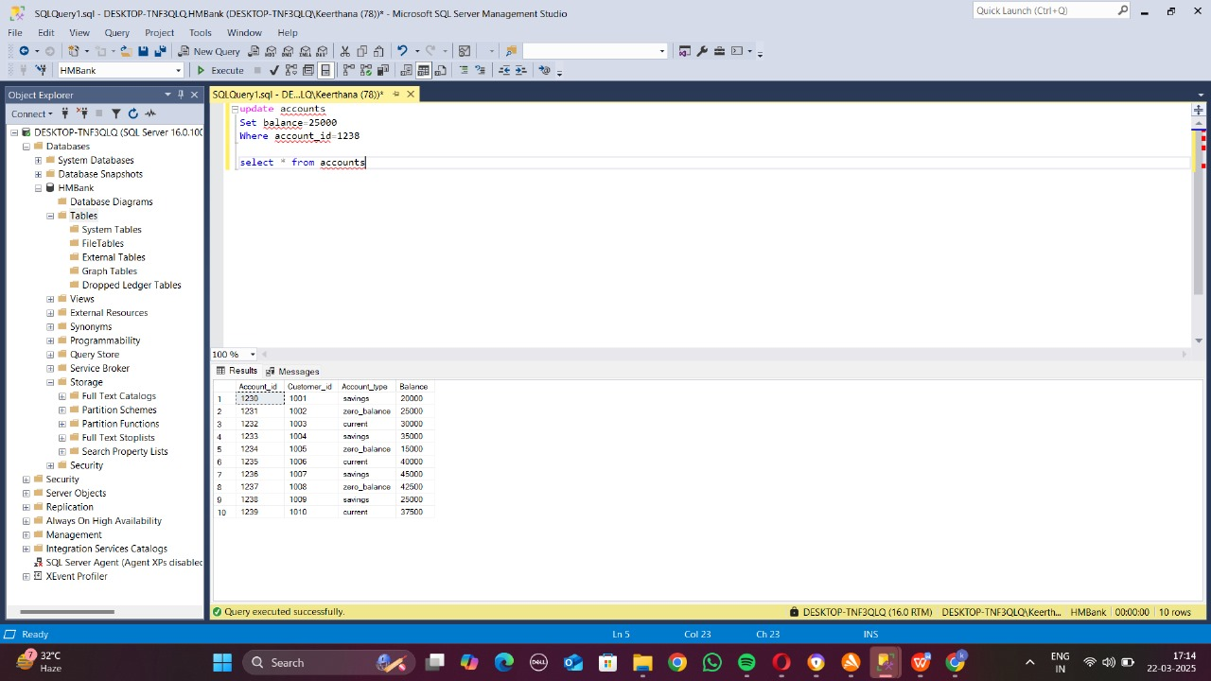

4)select first_name + ‘ ‘ + last_name as ‘full_name’

From customers

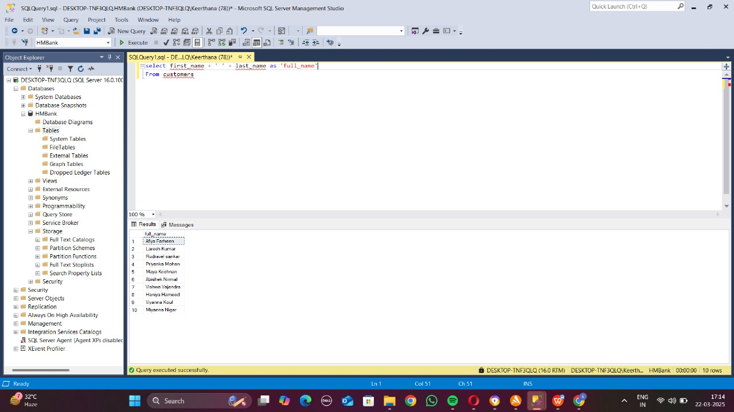

5)delete from accounts

Where balance=0 and account_type=’savings’

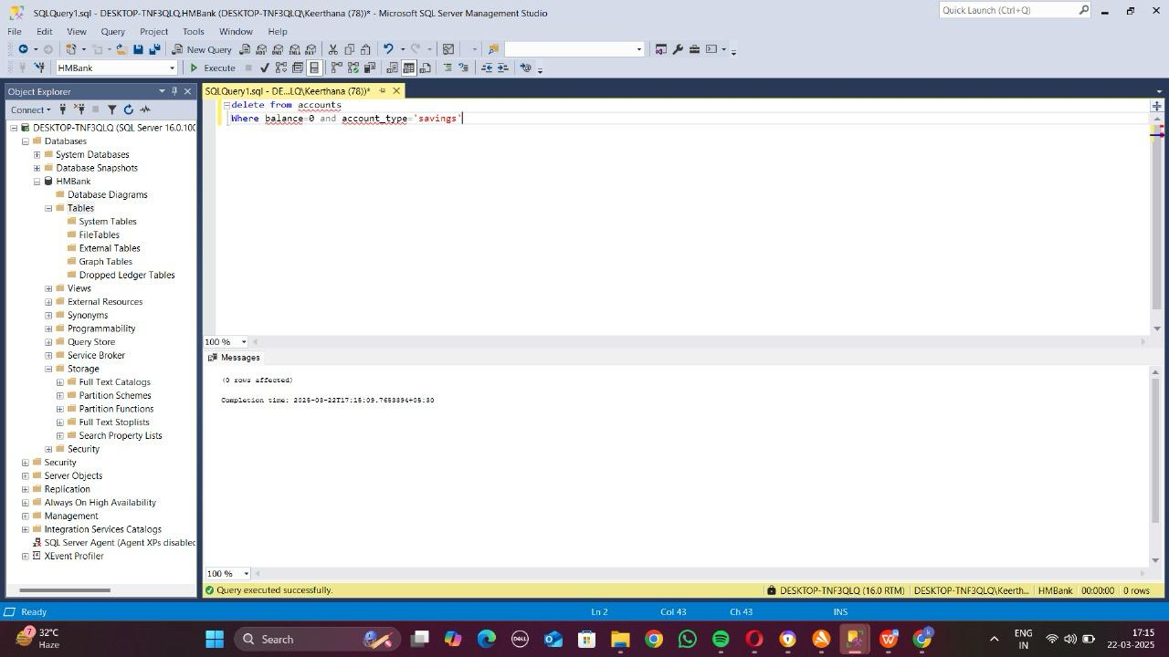

6)select * from customers

Where address like ‘%chennai%’

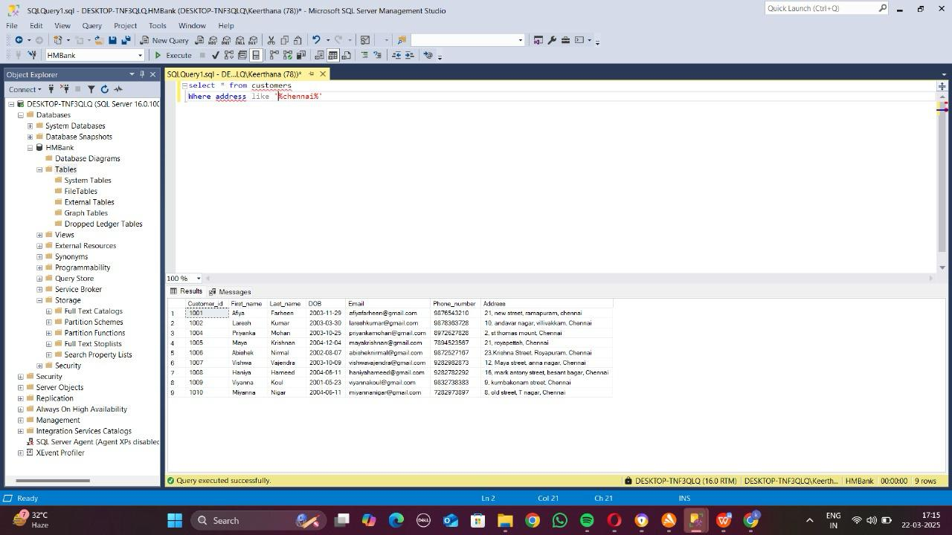

7)select balance from accounts

Where account_id=1234

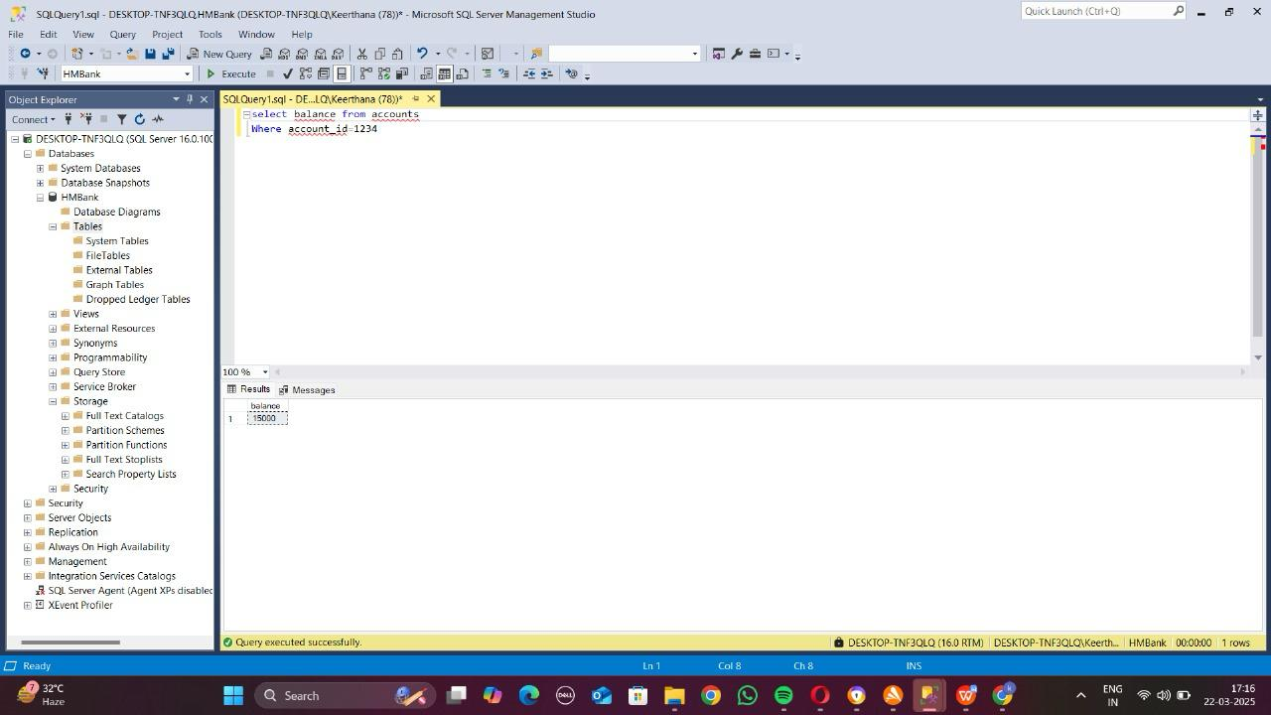

8)select * from accounts

Where balance>1000

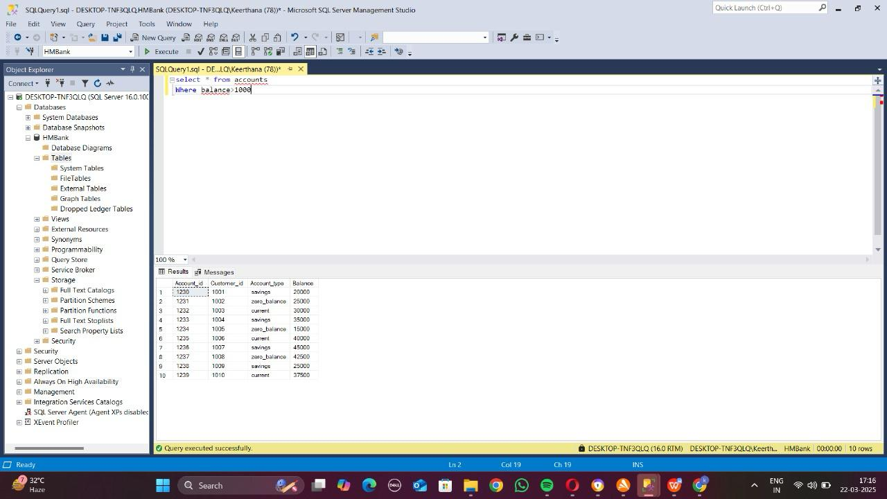

9) select *

From transactions

Where account_id = 1232

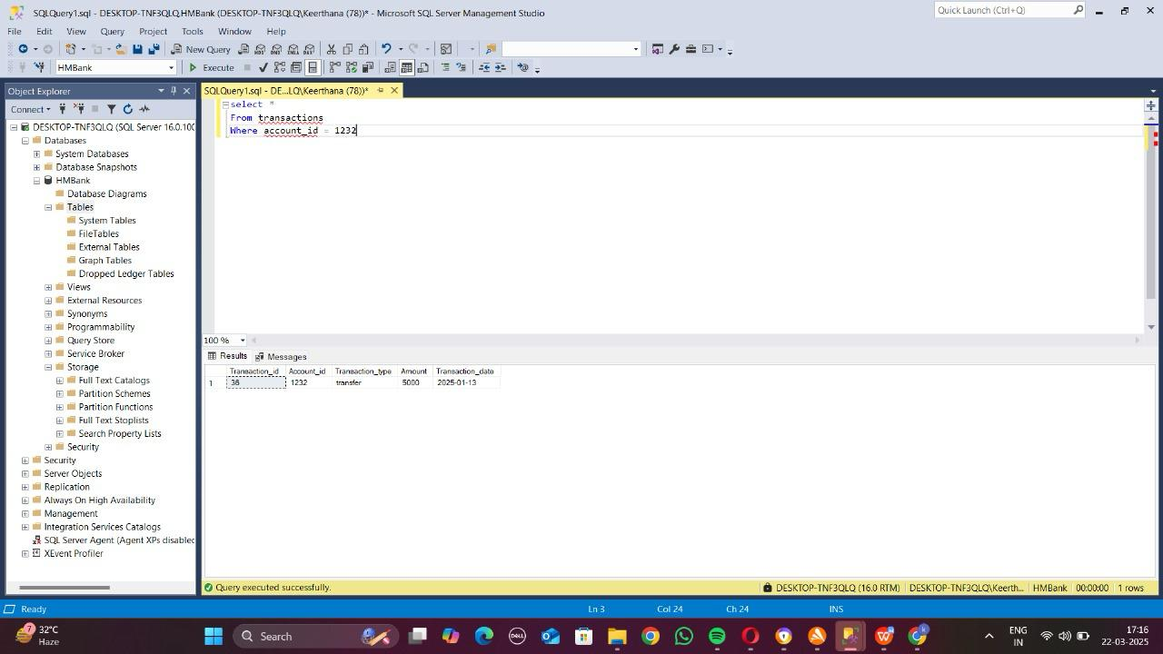

10) select account_id, account_type, balance*1*10/100 as ‘simple interest’

From accounts

Where account_type=’savings’

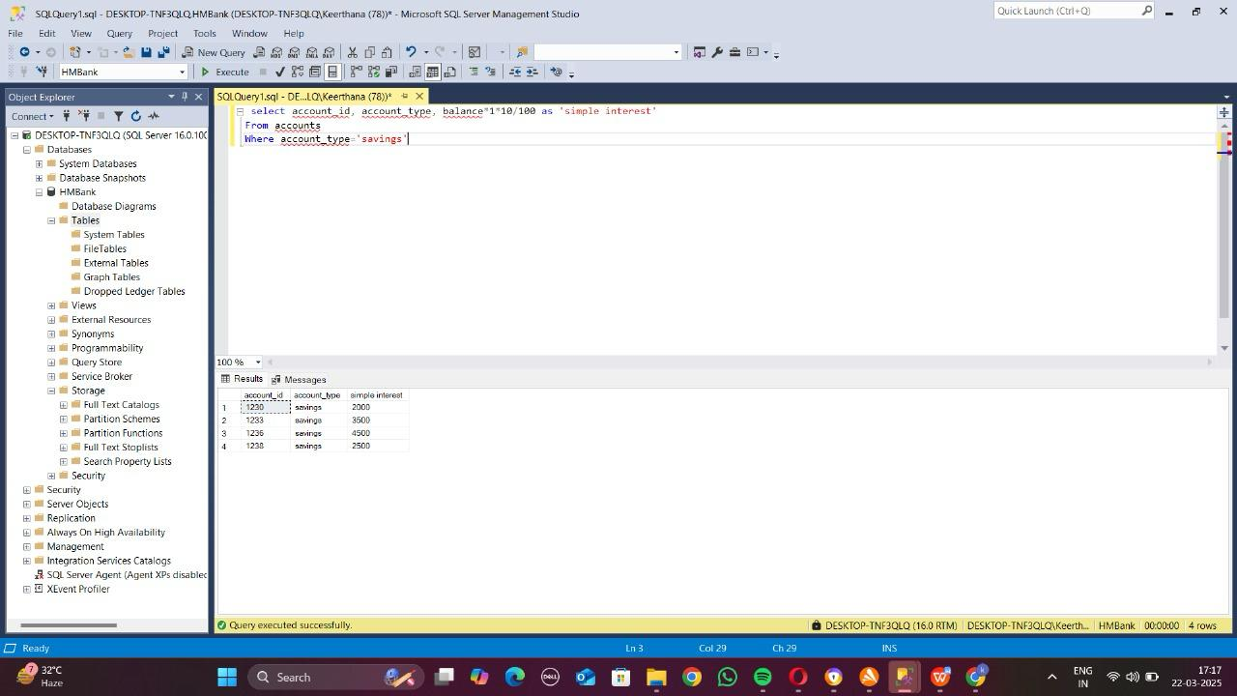

11) select * from accounts

Where balance<20000

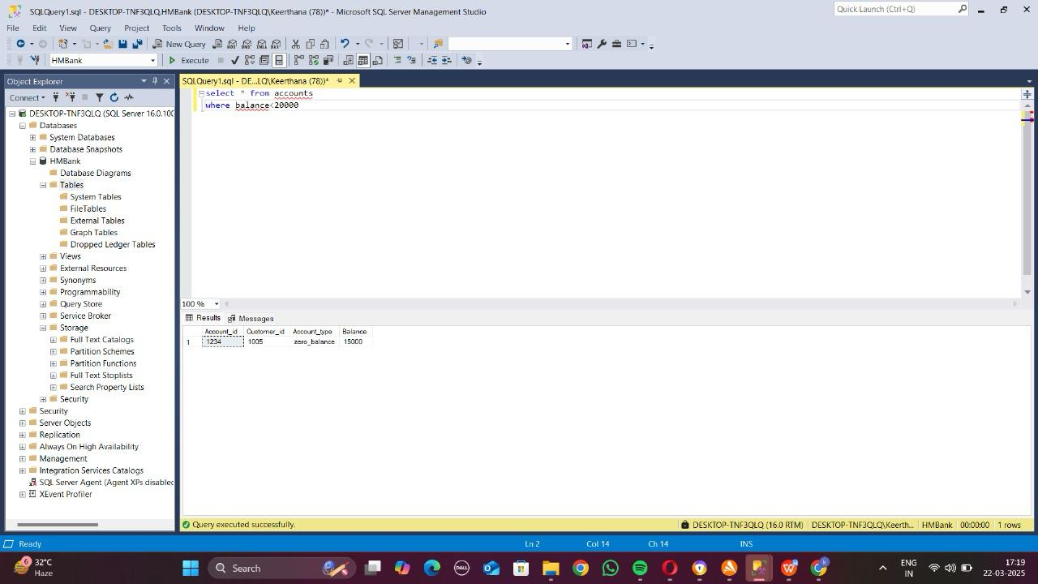

12) select * from customers

Where address not like ‘%chennai%’

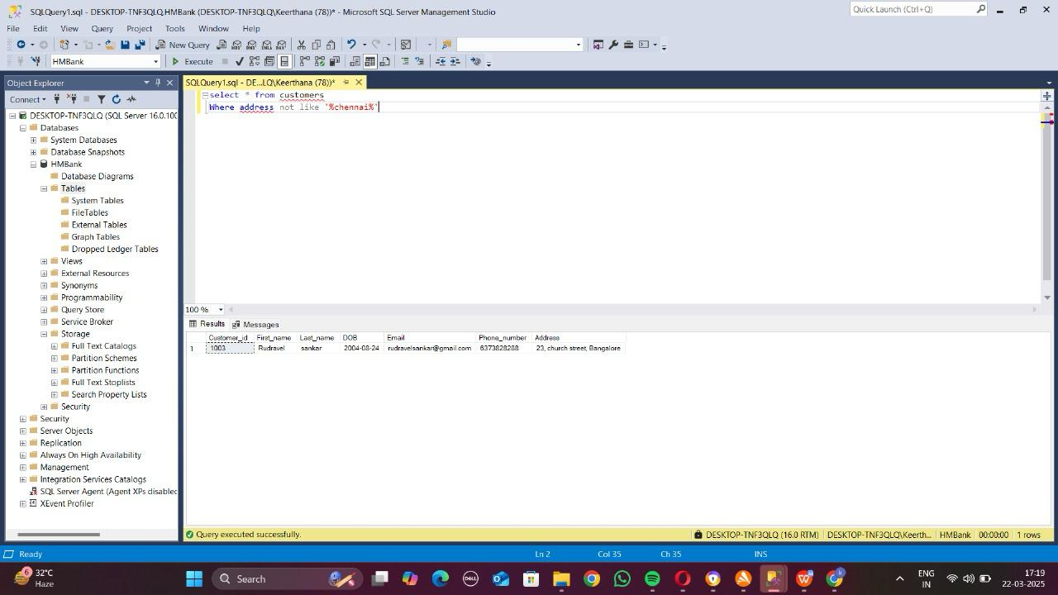

**Task 3:**

1)select avg(balance) ‘average balance’ from accounts

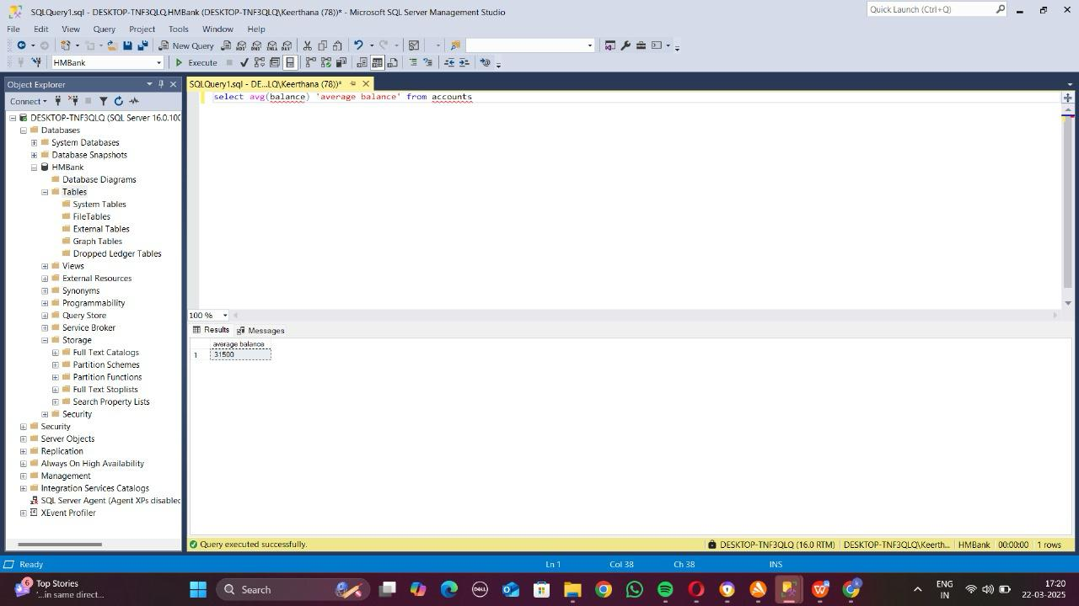

2)select top 10 balance from accounts

Order by balance desc

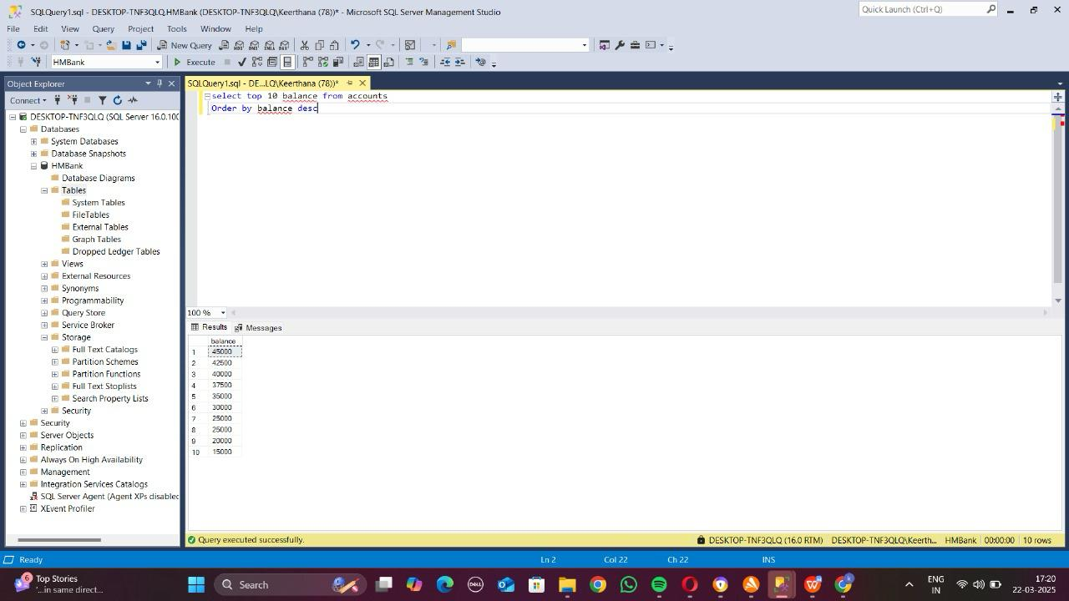

3)select sum(amount) ‘sum’

From transactions

Where transaction_type = ‘deposit’

And date = ‘2025-10-23’

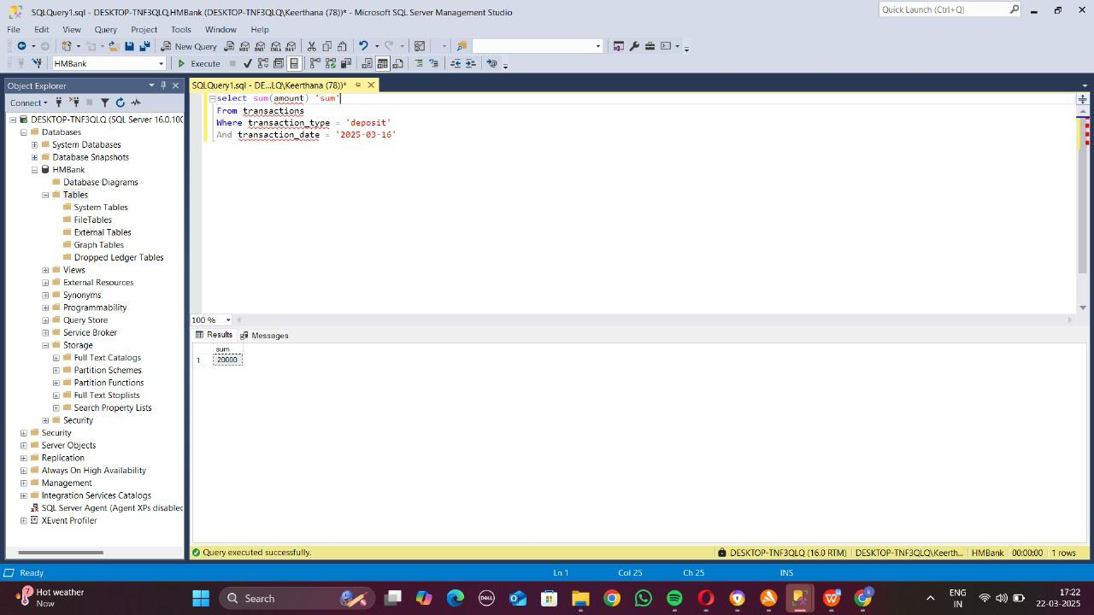

4)select top 1 * from customers

Order by DOB desc

Select top 1 * from customers

Order by DOB asc

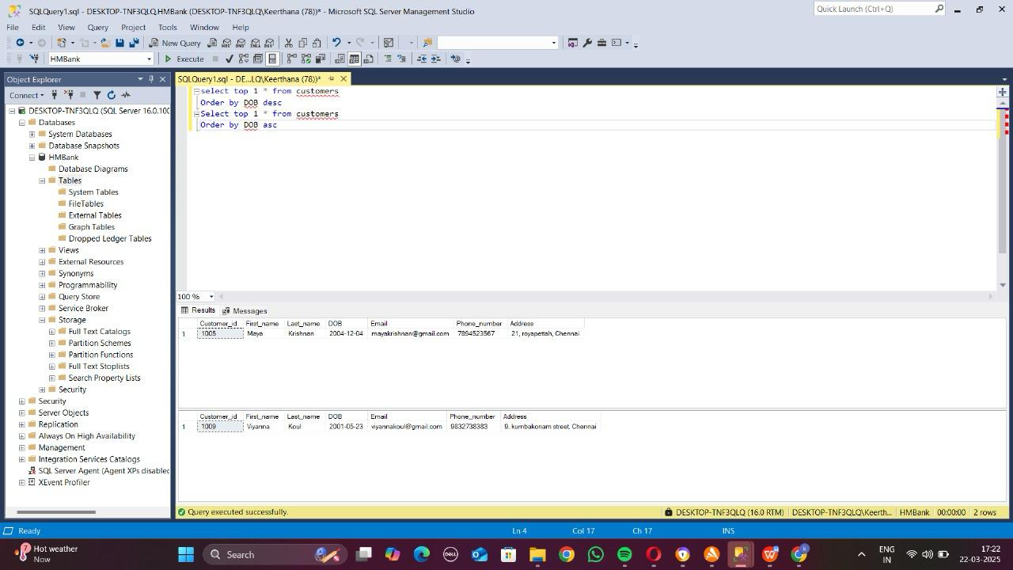

5) select t.transaction_id, t.account_id, t.trasaction_type, t.amount, t.transaction_date, a.account_type

From transactions t inner join accounts a

On t.transaction_id = a.account_id

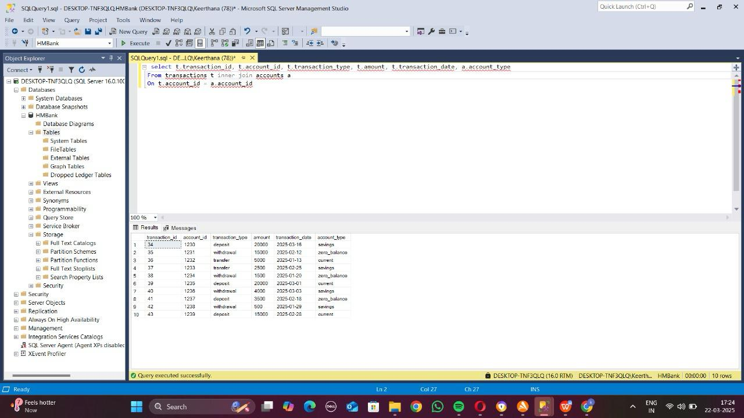

6) select * from customers inner join accounts

On customers.customer_id = accounts.customer_id

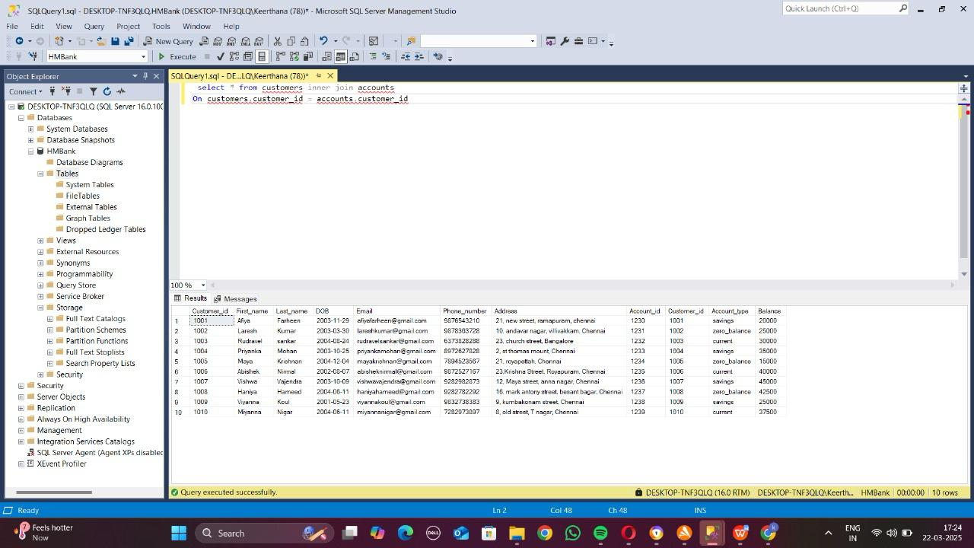

7) select * from customers, accounts, transactions

Where customers.customer_id=accounts.customer_id

And accounts.account_id = transactions.account_id

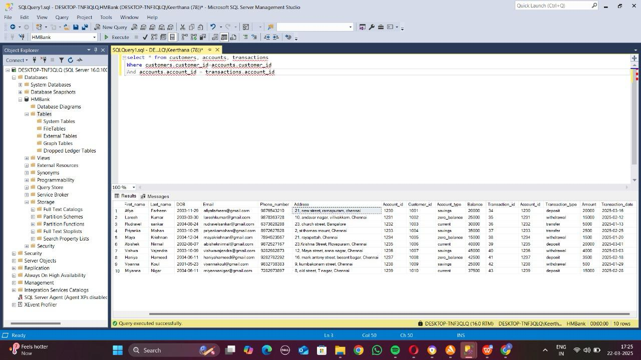

8) select c.customer_id

From customers c inner join accounts a

On c.customer_id = a.customer_id

Group by c.customer_id

Having count(*)>1

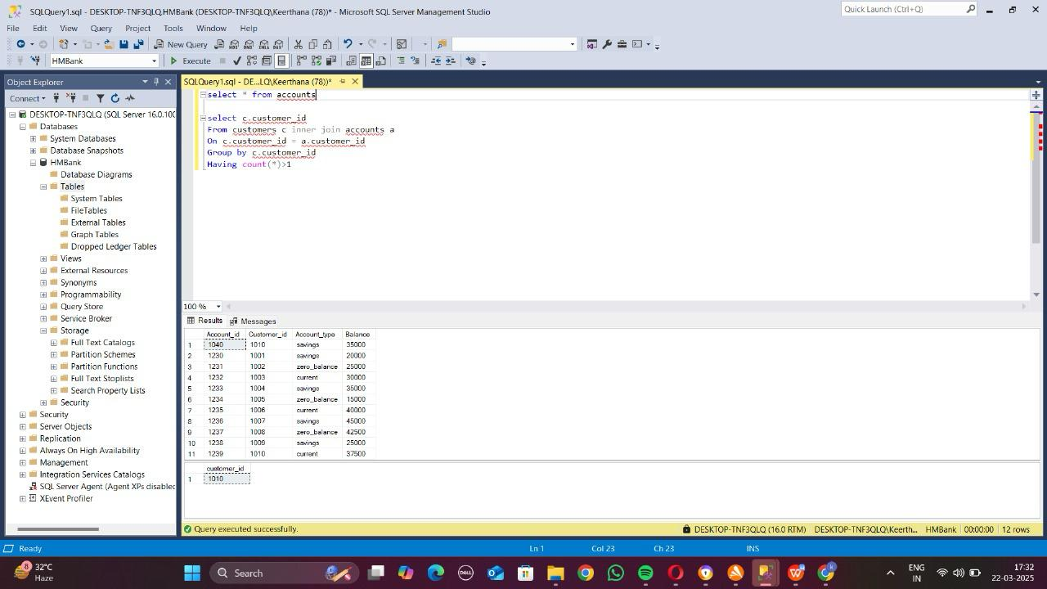

9) select sum(t1.amount)-sum(t2.amount) as ‘difference’

From transactions t1 inner join transactions t2

On t1.account_id=t2.account_id

Where t1.transaction_type=’deposits’

And t2.transaction_type=’withdrawal’

Groupby t1.account_id

10) Select avg(a.balance) as ‘average_balance’

From accounts a inner join transactions t

Where transaction_date between ‘2025-01-01’ and ‘2025-01-31’

11) select account_type, sum(balance)

From accounts

Group by account_type

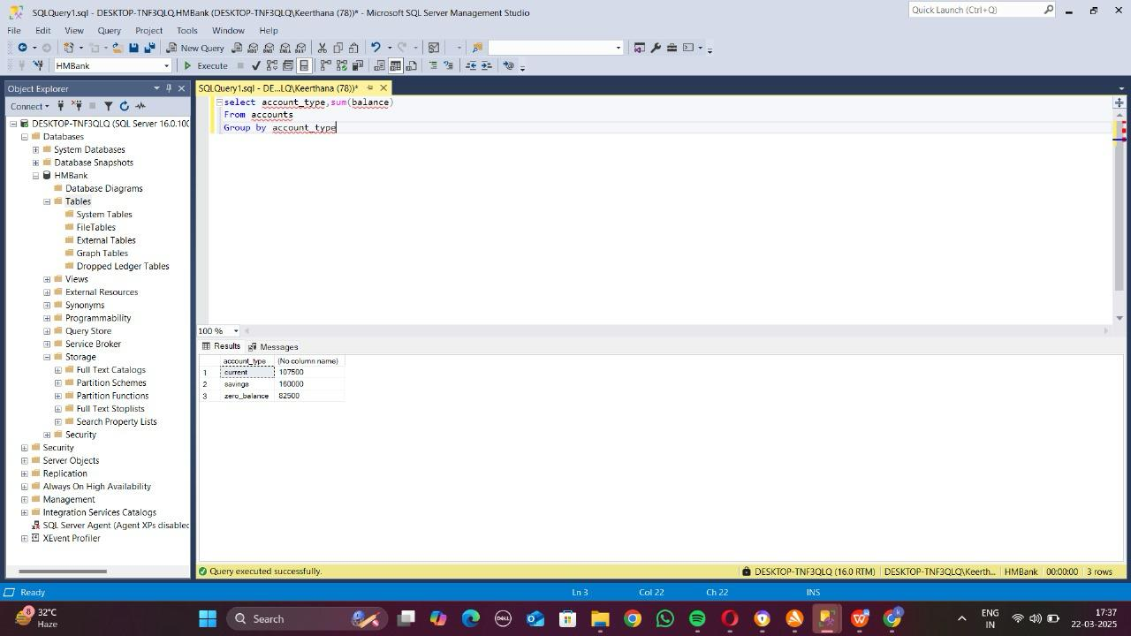

12) select a.account_id

From accounts a inner join transactions t

On a.account_id = t.account_id

Group by a.account_id

Order by count(t.transaction_id) desc 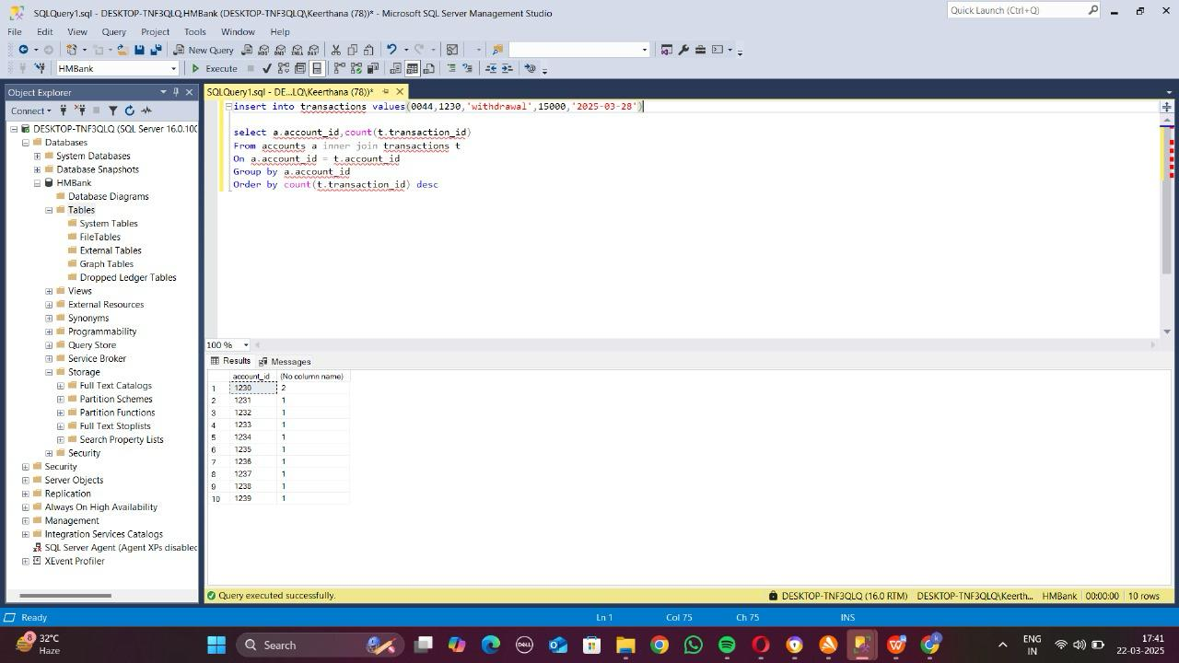

13) select c.customer_id, sum(a.balance)

From customers c inner join accounts a

On c.customer_id=a.customer_id

Group by c.customer_id

Order by sum(a.balance) desc

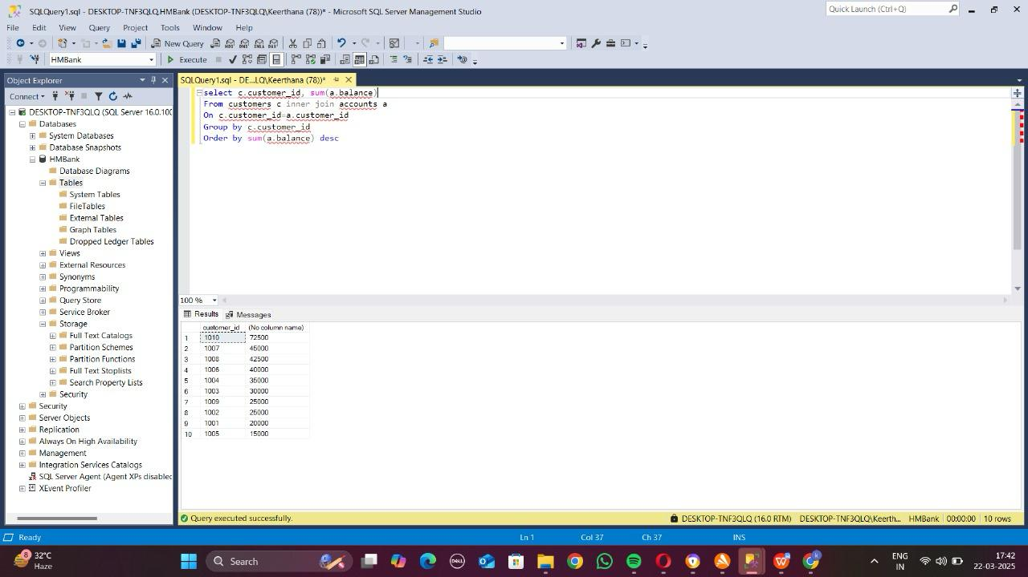

14) select * from transactions

Group by amount, transaction_date, account_id

Having count(*) > 1

**Task 4:**

1)select c.customer_id, c.first_name, c.last_name

From customers c inner join accounts a

On c.customer_id=a.customer_id

Where a.balance=(select max(balance) from accounts)

2) select avg(balance) from accounts

Group by (select customer_id from accounts

Group by customer_id

Having count(account_id)>1)

3)select * from accounts a inner join transactions t

On a.account_id=t.account_id

Where amount> (select avg(amount) from transactions)

4)select * from customers

Where customer_id in (select a.customer_id

from accounts a left join transactions t

on a.account_id=t.account_id

where transaction_id is null)

5)select balance from accounts

Where account_id in (select a.account_id

from accounts a left join transactions t

on a.account_id=t.account_id

where transaction_id is null)

6)select * from transactions

Where account_id in (select account_id from accounts

Where balance=(select min(balance) from accounts))

7) select * from customers

Where customer_id in (select customer_id

From accounts

Group by customer_id

having count(DISTINCT account_type)>1)

8) select a.account_type, (count(a.account_type)/count(*))*100 as ‘percentage’

Group by a.account_type

From accounts a

9)select * from transactions

Where account_id in (select account_id from accounts

Where customer_id=1002)

10)select a.account_type, (select sum(balance)

From accounts where account_type=a.account_type) as ‘total balance’

From accounts a

Group by a.account_type